Wyatt Duberstein

COMS 363

February 11th, 2021

Homework 1

**ProjectDB**

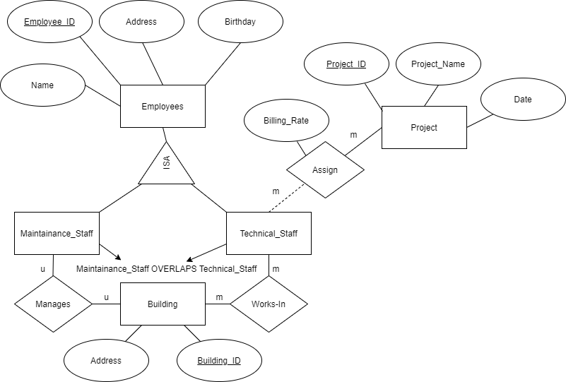

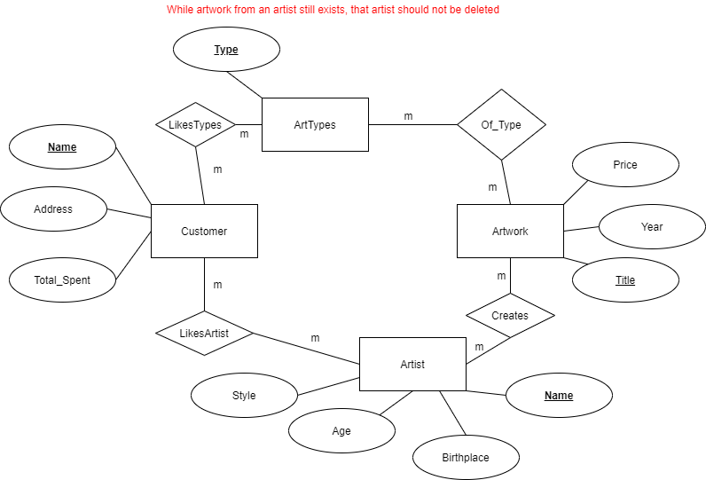**ArtBase**

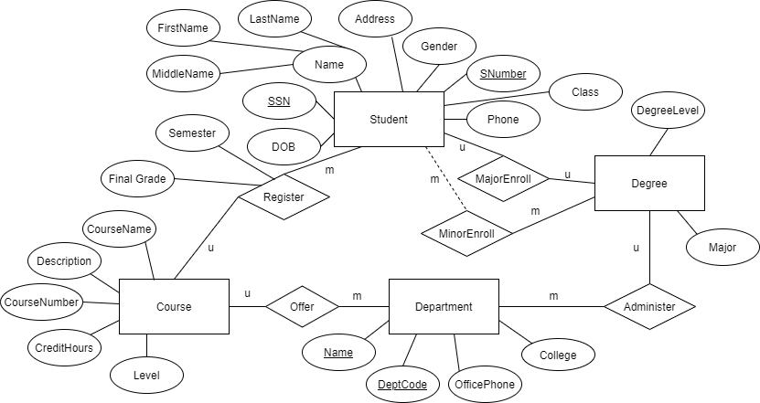**UniversityDB**